**Heterogeneous effects of work horizon increase (ΔYTR >0) on depression (EuroD (0-12)) depending on working conditions**

|  |  |  |  |  |
| --- | --- | --- | --- | --- |
|  |  | **All individuals** | **Males** | **Females** |
| **Full** | | -0.151  (0.488) | -0.588  (0.548) | 0.482  (0.291) |
| **JQI physical environment** | **<= mean - sd**  **>= mean + sd**  *p-value for equality* | 0.488  (0.429)  0.111  (0.725)  *0.533* | 1.333*  (0.644)  -0.473  (0.660)  *0.031* | 1.567**  (0.543)  0.752  (0.692)  *0.040* |
| **JQI social environment** | **<= mean - sd**  **>= mean + sd**  *p-value for equality* | 0.184  (0.642)  -0.169  (0.551)  *0.433* | 0.143  (0.525)  0.348  (0.706)  *0.779* | 1.464***  (0.293)  1.080*  (0.586)  *0.522* |
| **JQI skills and discretion** | **<= mean - sd**  **>= mean + sd**  *p-value for equality* | -0.356  (0.724)  0.283  (0.961)  *0.214* | -0.423  (0.724)  -0.824  (0.619)  *0.597* | 1.554  (0.927)  1.944**  (0.692)  *0.645* |
| **JQI working time quality** | **<= mean - sd**  **>= mean + sd**  *p-value for equality* | 0.677  (0.510)  0.293  (0.527)  *0.513* | 1.451*  (0.720)  -0.435  (0.347)  *0.027* | 0.823  (0.529)  0.839  (0.792)  *0.980* |
| **JQI intensity** | **<= mean - sd**  **>= mean + sd**  *p-value for equality* | 1.538***  (0.338)  -0.602  (0.452)  *0.001* | 0.264  (0.382)  -1.177*  (0.639)  *0.013* | 1.474***  (0.468)  1.287  (0.759)  *0.456* |
| **JQI prospects** | **<= mean - sd**  **>= mean + sd**  *p-value for equality* | 0.179  (0.768)  -0.788  (0.754)  *0.017* | 0.348  (0.575)  -1.852**  (0.812)  *0.000* | 1.492*  (0.746)  1.135*  (0.570)  *0.617* |

* p<0.1, ** p < 0.05, ***p < 0.01

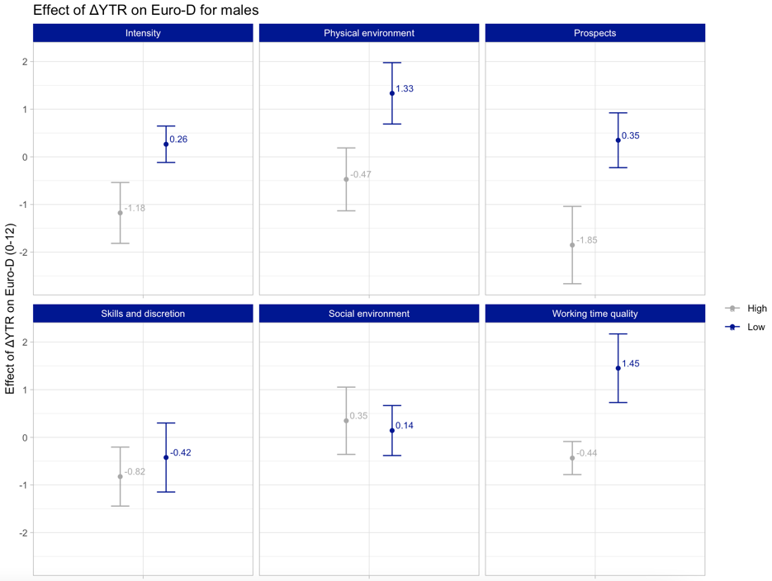

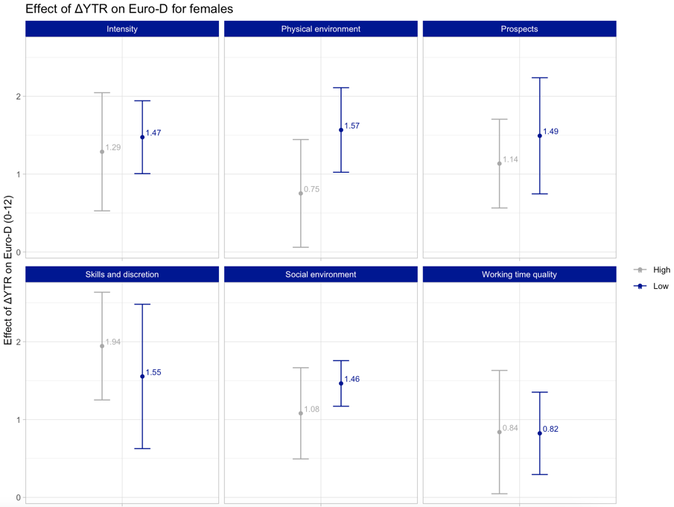

**Heterogeneous effects of work horizon increase (ΔYTR >0) on the probability of depression (EuroD > 3) depending on working conditions**

|  |  |  |  |  |
| --- | --- | --- | --- | --- |
|  |  | **All individuals** | **Males** | **Females** |
| **Full** | | -0.003  (0.078) | -0.046  (0.081) | 0.081  (0.065) |
| **JQI physical environment** | **<= mean - sd**  **>= mean + sd**  *p-value for equality* | 0.158  (0.125)  0.110  (0.176)  *0.735* | 0.162*  (0.085)  -0.090  (0.141)  *0.040* | 0.572***  (0.176)  0.320*  (0.173)  *0.040* |
| **JQI social environment** | **<= mean - sd**  **>= mean + sd**  *p-value for equality* | 0.155  (0.110)  0.034  (0.257)  *0.433* | 0.197*  (0.099)  -0.057  (0.155)  *0.179* | 0.492***  (0.078)  0.396**  (0.157)  *0.647* |
| **JQI skills and discretion** | **<= mean - sd**  **>= mean + sd**  *p-value for equality* | -0.041  (0.119)  0.052  (0.184)  *0.407* | 0.023  (0.085)  -0.223  (0.156)  *0.021* | 0.382***  (0.115)  0.499**  (0.180)  *0.421* |
| **JQI working time quality** | **<= mean - sd**  **>= mean + sd**  *p-value for equality* | 0.217*  (0.125)  0.213  (0.138)  *0.923* | 0.280*  (0.131)  -0.011  (0.108)  *0.073* | 0.401**  (0.142)  0.435**  (0.181)  *0.844* |
| **JQI intensity** | **<= mean - sd**  **>= mean + sd**  *p-value for equality* | 0.375***  (0.101)  -0.029  (0.055)  *0.000* | 0.196  (0.188)  -0.116*  (0.065)  *0.052* | 0.472***  (0.108)  0.523**  (0.184)  *0.926* |
| **JQI prospects** | **<= mean - sd**  **>= mean + sd**  *p-value for equality* | 0.208  (0.222)  -0.077  (0.166)  *0.008* | 0.248**  (0.103)  -0.249*  (0.120)  *0.000* | 0.724***  (0.123)  0.394**  (0.133)  *0.056* |

* p<0.1, ** p < 0.05, ***p < 0.01